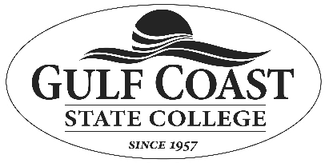
Gulf Coast State College 5230 West U.S. Highway 98 Panama City, Florida 32401

Verification of Employment - Registered Nurse First Assistant (RNFA) Program
Section I : Student Completes:
The potential student is to fill out this section, date, sign it, and send it to the place of employment. Please PRINT the following Information:
Name: _
Name at time of employment if different: SSN (last 4 digits): XXX-XX- Place of employment: Approximate dates of employment: _ Job position held:
I hereby authorize the Human Resources Department or other department of the above-listed place of employment to release the information or confirmation of the information listed above. Additionally, I release Gulf Coast State College and the place of employment listed above from all liability whatsoever for issuing the requested information.
Student Authorizing Signature
Date

Next, give to the appropriate person at your place of work to complete Section II.

Section II: Human Resources or Manager Completes:

I certify that the records of (company) reveal the following on the person identified above.
Above information is correct.
Above information is correct with this exception:
Unable to verify information due to:

Please verify employment of the above-named person and return this form via e-mail to bpage2@gulfcoast.edu. Printed name of person verifying employment: Signature: Position: Date: Telephone #

Thank you,

Brittany Page, BAS, CSFA, CST Coordinator, Surgical Services

