Step 1: Submit Your Peer Review Application
Use this job aid or watch the video tutorial for step-by-step instructions describing how to apply for a GCSC peer review through Quality Matters (QM).

Select this link to go to the Quality Matters sign-in page. You can also search for “MyQM login” on Google. Use your credentials to sign in. If you’ve forgotten your password, select “Forgot Password?” and an email will be sent with instructions to reset it.
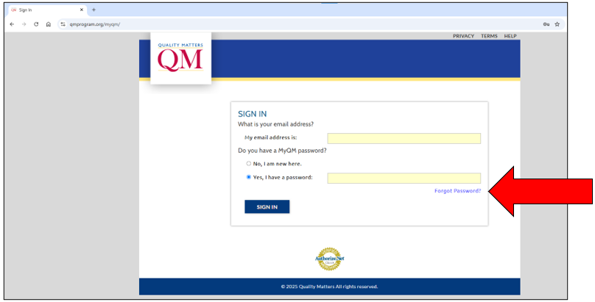

After logging in, select “MyCR” to start a review application. Make sure you are on the “Higher Education” tab.
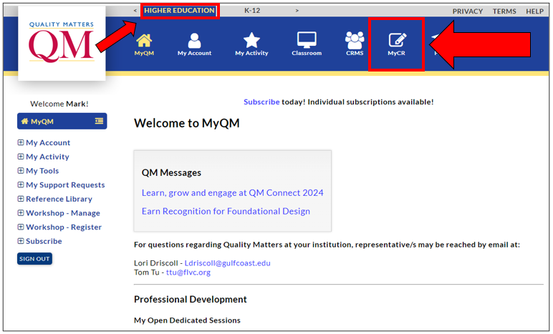

Select “Start a Review Application.”
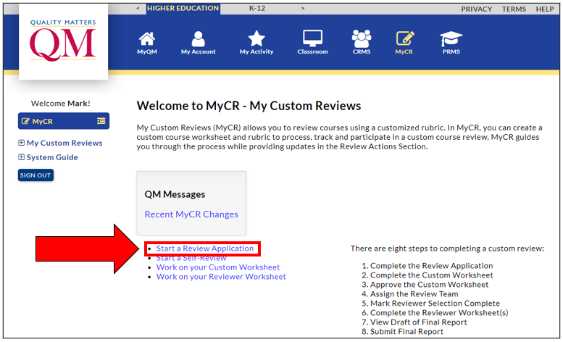

Confirm Gulf Coast State College as the institution.
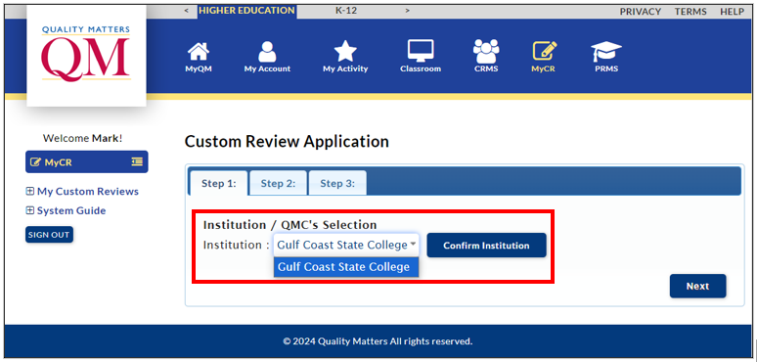

Select “Lori Driscoll” as the QM Coordinator from the “Select a QMC” dropdown menu.
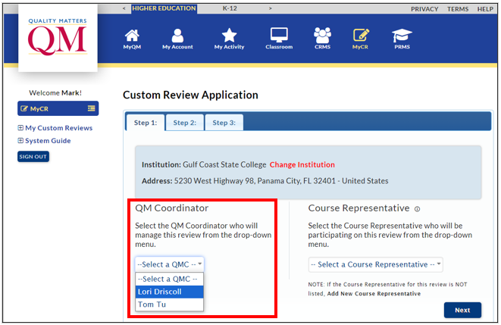

Look for your name in the “Select a Course Representative” dropdown menu, and select it.
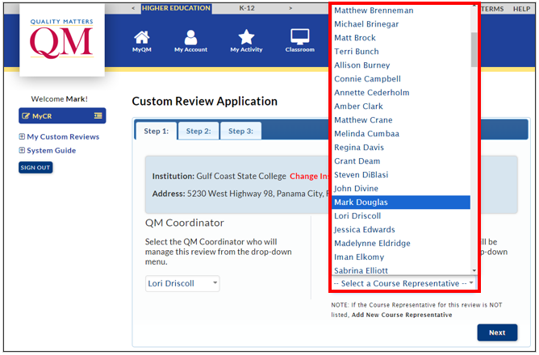

Select “GCSC QM Essentials Rubric (2025)” from the list of Custom Rubric options.
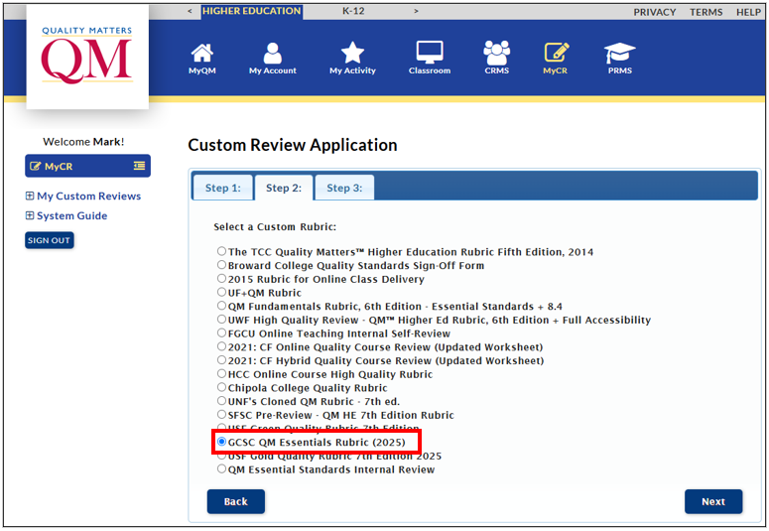

Fill in the textboxes and select from the dropdown menus to document the following information:
- Course Number [Prefix, Number, & Instructor’s Last Name: EDU 1101 Douglas]
- Course Name
- Brief Course Description
- Course Management System [Canvas]
- Course Discipline [Business, Literature, Nursing, Social Science, etc.]
- Format of the Course [Asynchronous, Hybrid, Synchronous Online]
- Select “No” when answering if the course is continuing education
- Submit Application
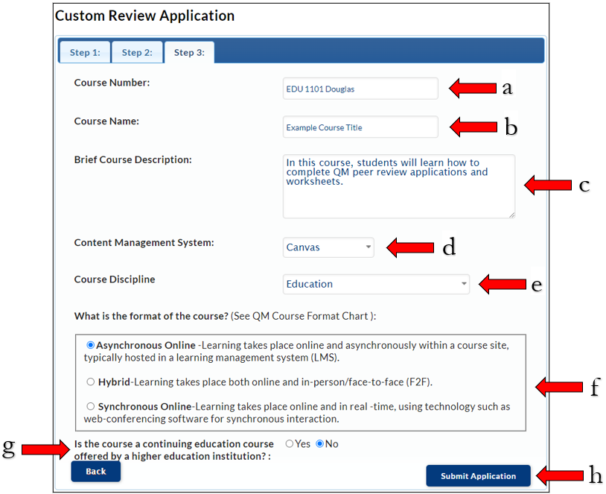

Step 2: Complete Your Custom Worksheet

After submitting your QM Peer Review application, you’re almost done! Complete your Custom Worksheet so the QM Coordinator will be notified that your course is ready for peer review.

On the MyQM website, select the MyCR tab, then “Work on your Custom Worksheet.”
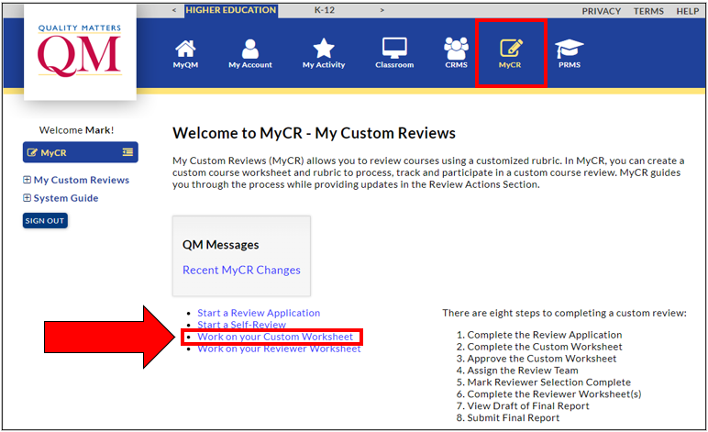

Select the “Courses I’ve Submitted for Review” tab (1). Then select the icon beside your course that resembles a page (2).
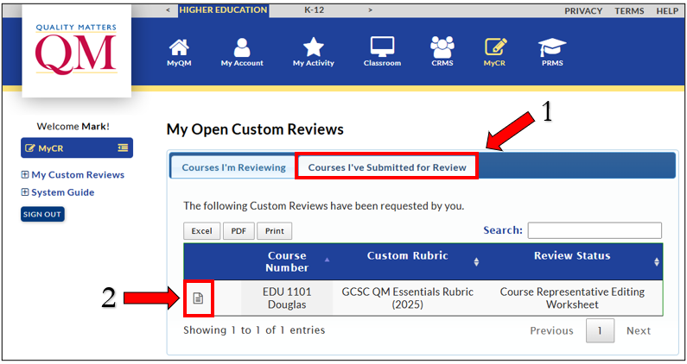

Select “Edit” on the View Custom Review Details page.
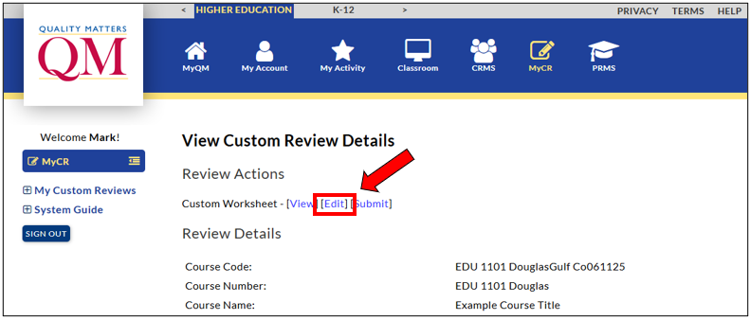

Complete and submit the Custom Worksheet with all requested attachments. Some questions require you to simply select an answer (1), while others will ask you to type out a response (2). If a question does not apply to your course, type N/A for not applicable.
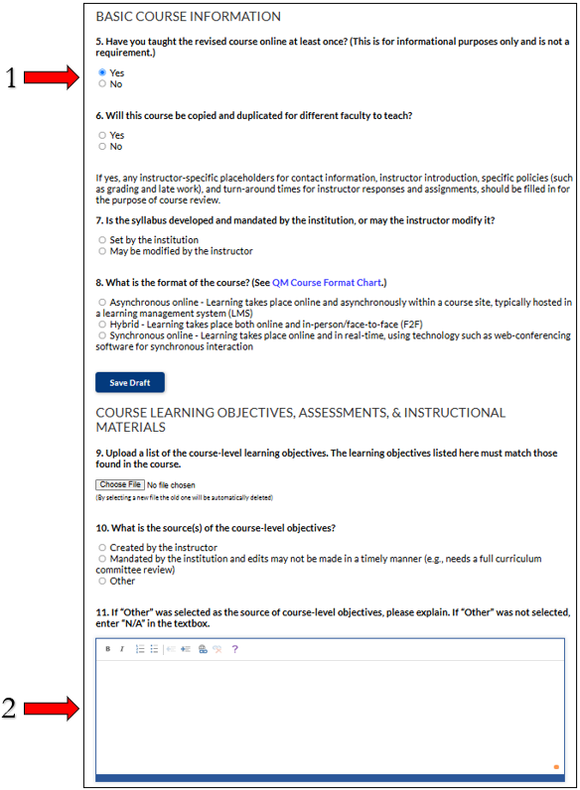

Upload the requested attachments: 1) a list of your course-level learning objectives, 2) a list of your module/unit-level learning objectives, and 3) your course map.
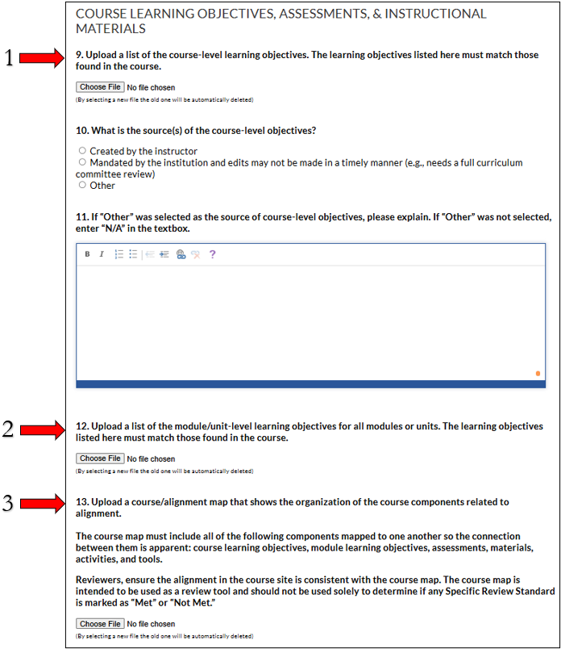

If you need to complete your QM worksheet at a later time, select “Save Draft” (1). When your QM worksheet is ready for submission, select “Submit Complete Worksheet” (2).
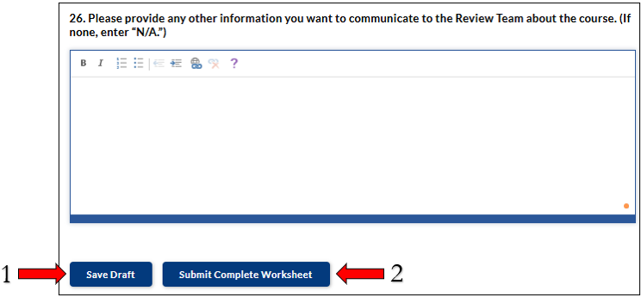

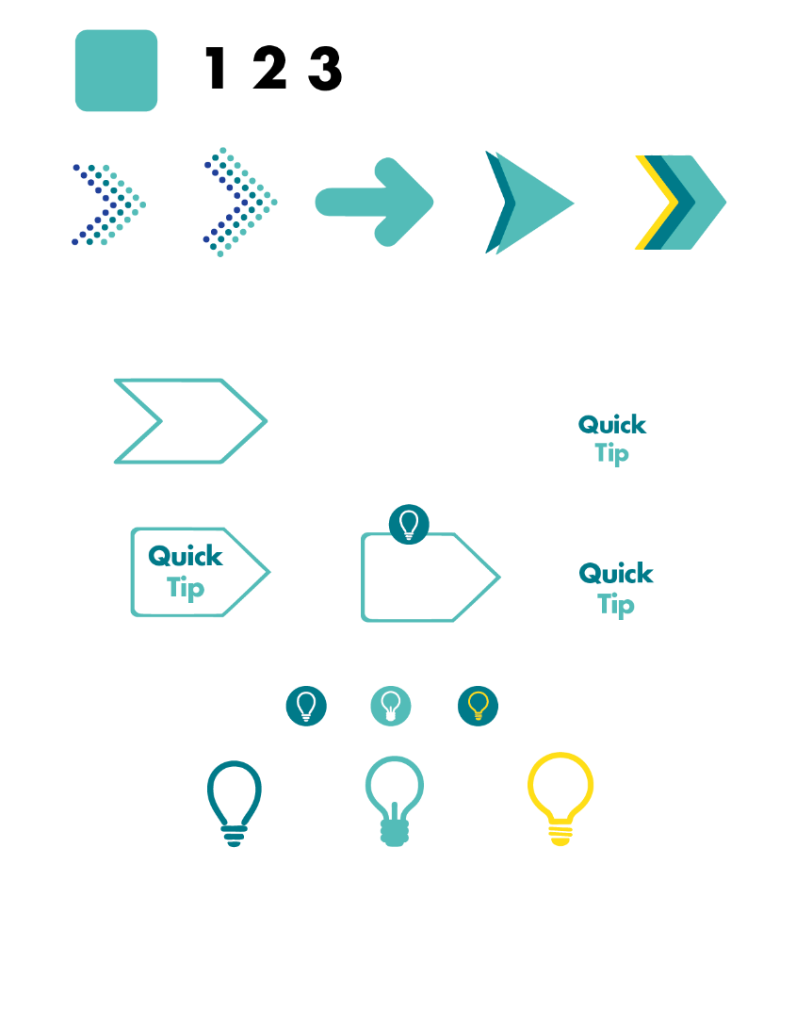
When both your Application and Worksheet are complete, the QM Coordinator will assign your course to a review team, and the Chair will contact you to schedule a meeting.

