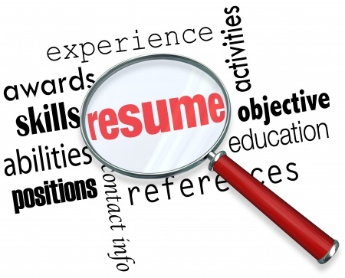
Resume meet, eat, & critique

Bring your resume in to be critiqued by career specialists from Gulf Coast State College, FSU-PC, and Career Source Gulf Coast. Lunch will be provided to all those with copies of their resume.

Celebrating National Career Development Month!

November 7, 2018

12:00PM – 2:00PM

Student Union East

Private Dining Room

